High Ratio Transfer Case Modification

This modification is for the fitment of a high ratio gear set into a standard series transfer case, the standard series transfer case is to be modified and 2x pin bushes are to be machined for the relocation of the centre pin to allow fitment of larger higher ratio gears.

We first start the modification of the series transfer case by relocating the centre pin location, mount the casing on a milling machine bed with the large centre pin hole facing upwards and the flat of the casing square to the bed in the ‘X’ orientation.
Use a centre finder or a dial test indicator (DTI) to find the absolute centre of the large pin hole.

Index to the following…
X 5.715mm
Y -1.285mm

Bore a new hole in this position at a diameter of 53.33mm ~ 53.35mm

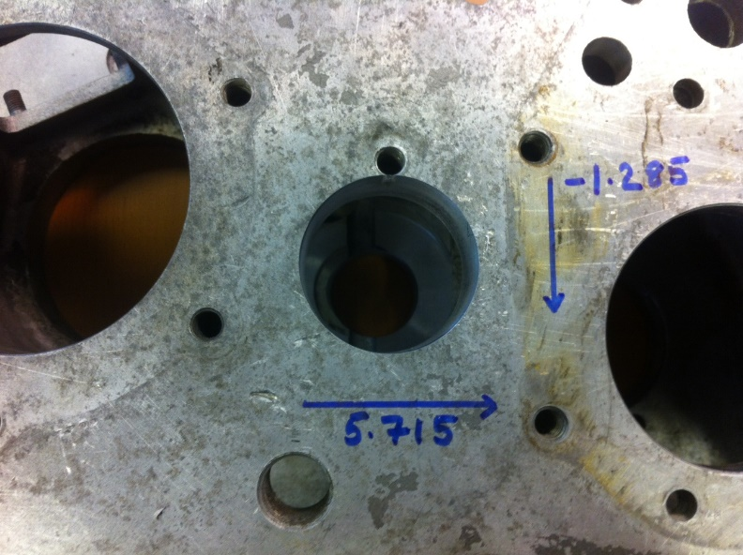

We need to now clean up the inner face of the bore whilst the machine is centered to accept the tabbed thrust washer (can reuse your own), for this procedure we use a custom back cutting tool and skim the inner face flush to the prior machined face as shown below.

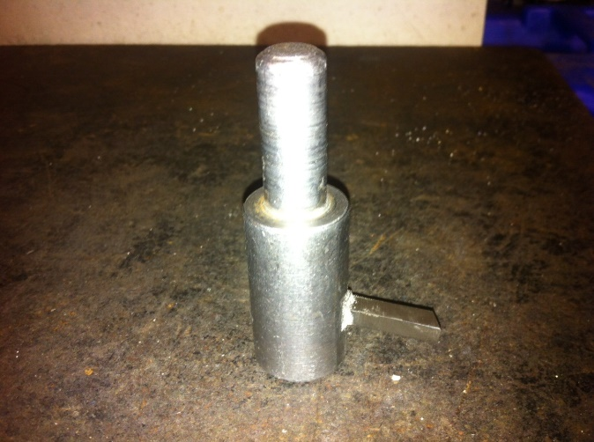
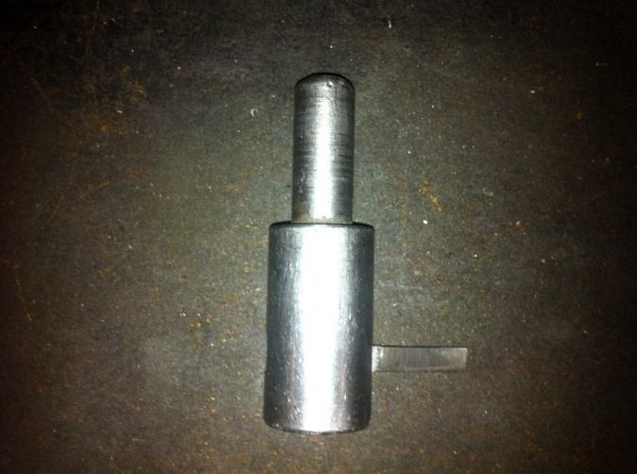

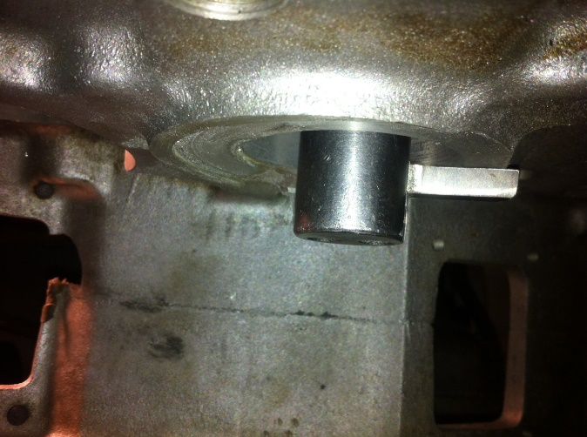
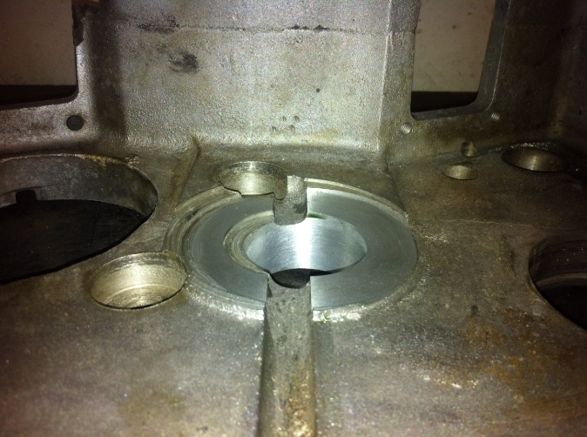

Turn the casing over so the small pin hole is now facing upwards, square the flat of the casing with the bed of the milling machine and centre the small pin hole as described before.

Index to the following…
X -5.890
Y -1.320

Bore a new hole in this position at a diameter of 41.26mm ~ 41.28mm

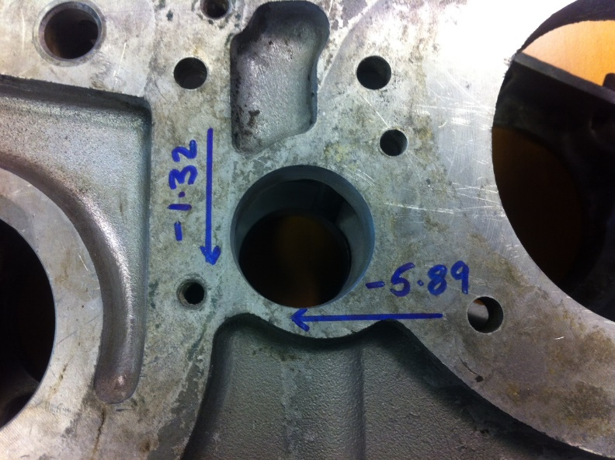

Clean the inner face again using the custom tool until flush with the prior machined face.

Now we are ready to machine the aluminum pin bushes, below are the drawings specified in millimeters for the pin bushes.

Large

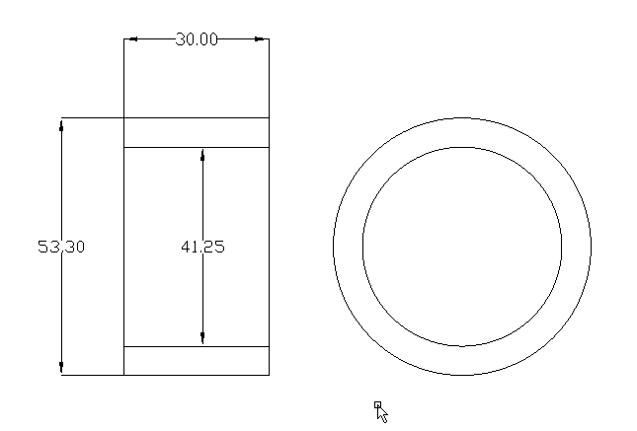

Small

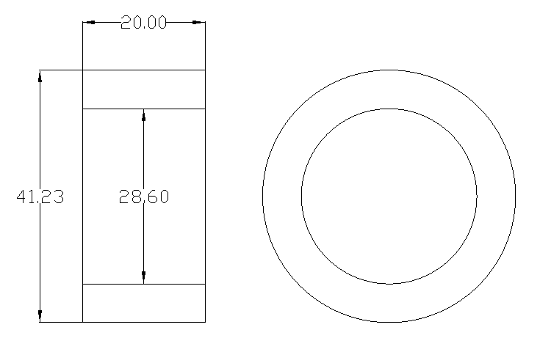

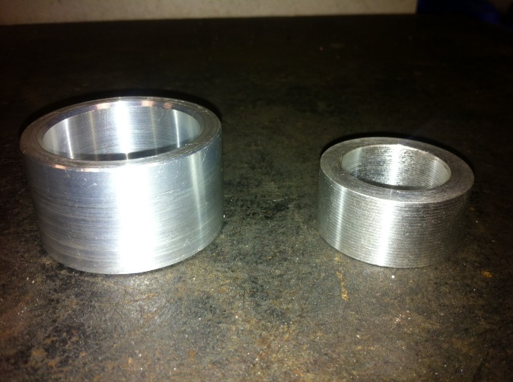
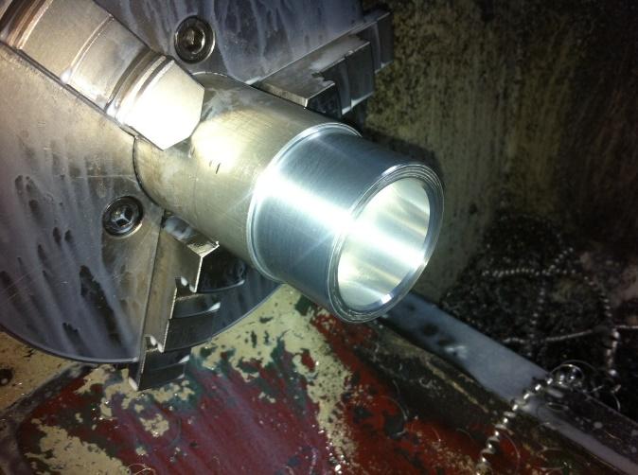

The pin bushes should both be a transition fit (sliding fit) on the centre pin and into the newly machined casing, apply a generous amount of bearing locktite onto the outer of the pin bushes and insert them into the corresponding holes in the machined casing ensuring they sit flush with the casing outer.

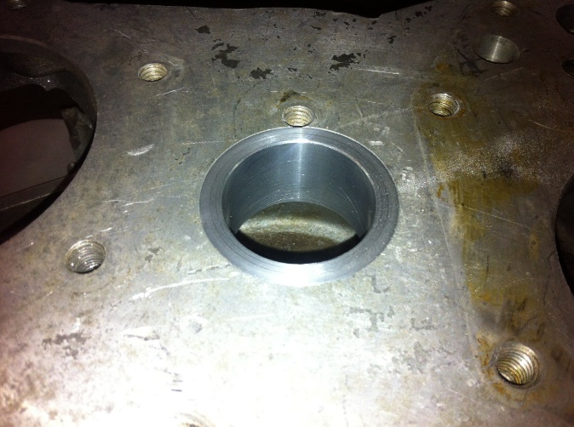

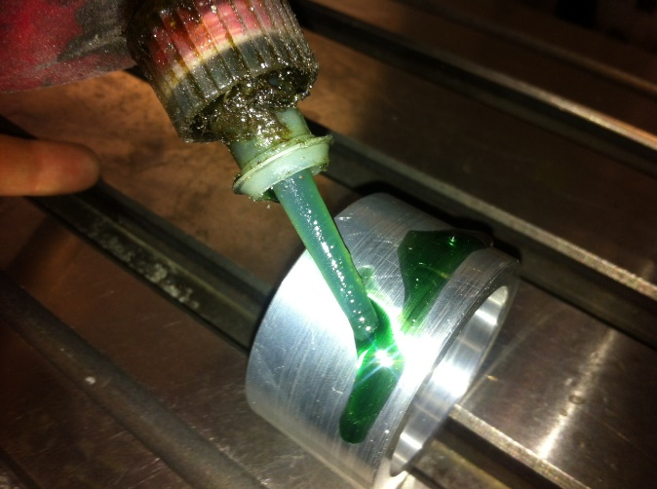

Apply a small amount of locktite to the rear of the tabbed thrust washer and lay the washer on the newly machined inner face of the small pin bush (the locktite is used for ease of assembly when installing the internals)
Insert the centre pin through the bushes adding a weight to the internal to hold the tab washer firm whilst the locktite sets. (Apply a very light coating of oil to the pin prior to insertion to avoid locktiteing the pin to the bushes from any locktite overspill that may occur)
Leave the casing with the large pin hole facing upwards and with the pin and weight inserted over night to allow all the applied locktite to set completely.

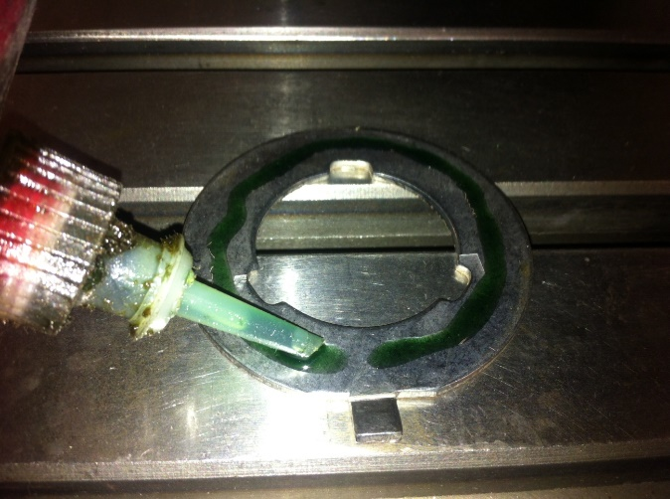
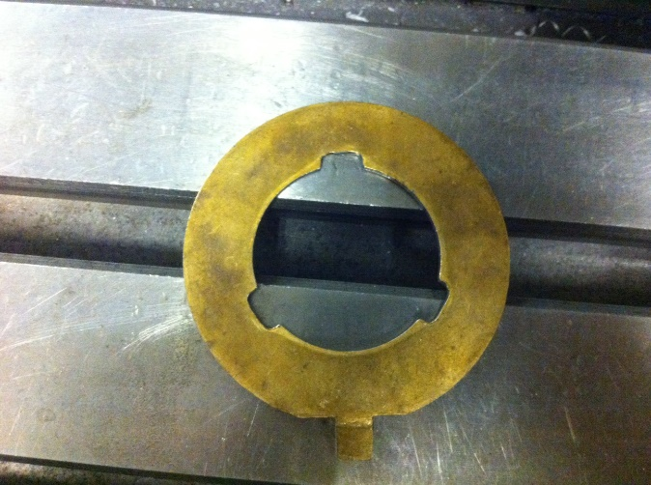

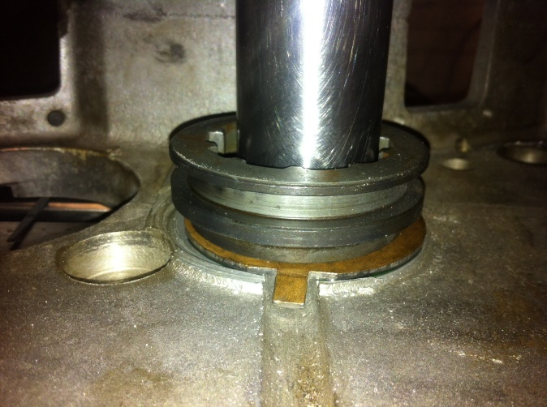
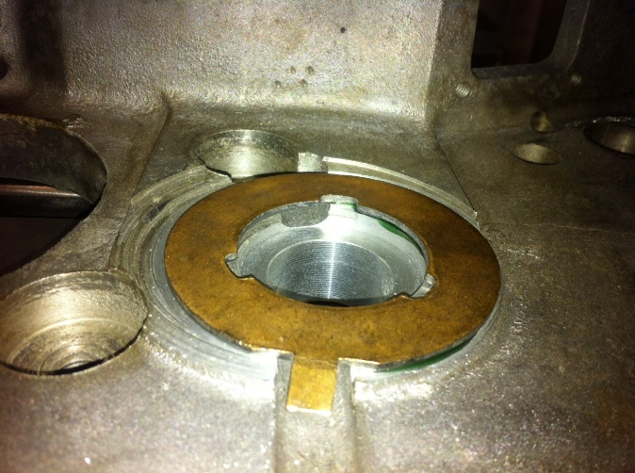

Once the locktite has set remove the pin and weight, there is a threaded hole that get broken into when boring the large pin hole. Run a tap through this hole to restore it back to normal. The thread is 3/8 UNC x16.

